AD5002
Representation: Researching, Thinking , Writing
Assessment 002

Select one of the following questions and write a 2000 word essay.

3. Eve Arnold uses the conventions of portrait photography to communicate and expresses ‘respect’ for her subject. Discuss this statement in relation to one of her photographs and in relation to another image by a photographer of your choice and analyse how they achieve their aim.

In this essay I will be discussing the conventions used by Eve Arnold to communicate and express ‘Respect’ for her subjects, in relation to a photograph taken made by her and in relation to an image taken by Henri Cartier- Bresson. And I will Explain how they achieve their aims.

“You want to go as deeply into them as people as you can. But usually what happens, if you’re careful with people and if you respect their privacy, they will offer part of themselves that you can use and that is the big secret,” Eve Arnold. -
Born to a poor immigrant family in Philadelphia 1912, Eve Arnold became a photographer by chance. Living in LongIsland at the time, a 38 year old house wife decided to enrol on a six-week photography course, (alongside Richard Avedon) which led to her groundbreaking, first photo publication with Picture Post in 1951, on the black fashion in Harlem, New York. Later joining Magnum Photo agency as one of the first woman photographers, parallel to Inge Morath in France at the time (1952). Eve’s only formal education was the six week photography course with Alexey Brodovitch at the New School for Social Research in New York. Whilst Working in a film processing lab her curiosity for the exploration of the world and others lives through journalism and photography was ignited. She had a new born at the time and wanted to develop herself as a mother, as a strong curious being in the world. Eve expresses this time in New York, early in her career as being, disastrous yet eye opening, Eve was thrown into a class of sixty photographers, who were all anxious to impress the master; Brodovitch who was the art director of Harper’s Bazaar an American women's fashion magazine. “The group used their criticism of my amateur attempts of photography to gain attention to themselves. Their criticism was savage. It was infuriating and chilling, but sadly accurate. I felt bruised but I listened. In a brief hour I learned the serious meaning of a photograph. It was my first step to professionalism.” What this shows is Eve’s mental strength, her resilience to being put down. She listened and took in what people had to say and learnt from it, from what sounds like being ripped apart for the work she had made so far and putting herself back together in a matter of minutes. Eve was ready to learn, to face the world again, to capture something original, and so she did. After finishing her course, for the rest of her career she was self-taught.

Eve’s most known photographs are from when she photographed Marilyn Monroe on the set of ‘Misfits’ with exclusive access given to Magnum photographers, Cornel Capa, Henri Cartier-Bresson, Bruce Davidson, Elliott Erwitt, Ernst Haas, Erich Hartman, Inge Morath and Dennis Stock - in the Nevada desert for the four month shoot. Eve said in an interview “Marilyn used both the camera and the photographer to keep her public image going.” Marilyn and Eve grew a strong bond with one another, a respect that is evident in the images of her, captured outside with the other actors and cast with in a pristine yet moody landscape. Inside with the intimacy and delicate nature of her representation, Monroe a pubic figure aware of the power of the still camera which would hold her representation well after she dies, knew where to place herself and how to look, most of which was an act of the fantasy she desired. Eve had an amazing ability to immerse herself with Marilyn and create an abstraction of her image as an icon, as a powerful yet delicate human to be desired.
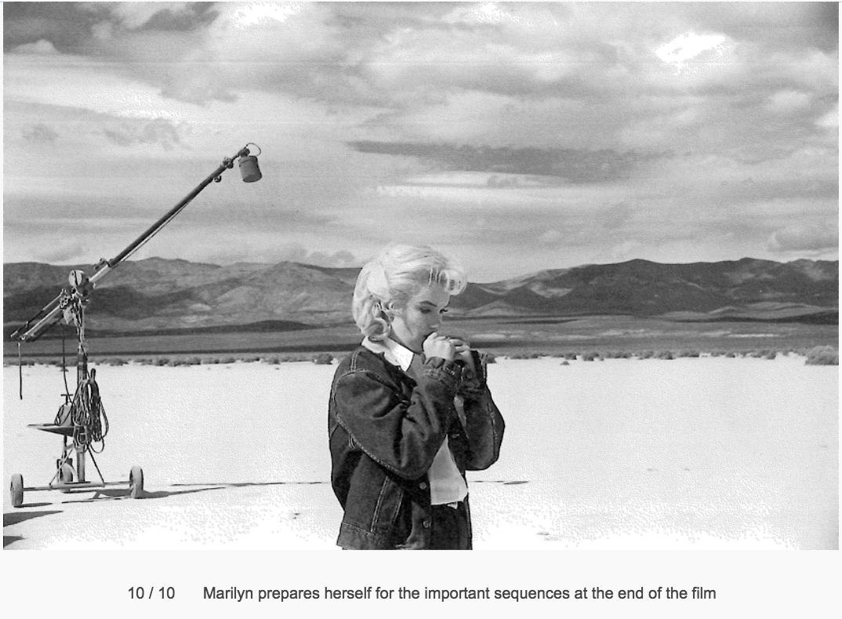
In figure 1 (below), ‘Marilyn prepares herself for the important sequences at the end of the film ‘, standing in the open, contrasting against the white sand, and the moody clouds above, Marilyn in the middle stares, in contemplation, holding onto herself with structures of the contemporary world in the background- the boom mic, like an all seeing eye recording and watching monroe at every level. Behind the scenes she was holding onto the last glimpse of her fantasy to become a world famous movie star as it was actually becoming a reality towards the end of the movie. This was too much for her. The full extent of the fantasy becoming a reality took its toll, the world was watching and communicating to her. In this image she looks lost, vulnerable, looking down at the mountains that reach onto the heavens above. To me this image reminds me of the atomic bomb test in the Nevada desert, only this time Marilyn is the bomb and her ideal is reflected in the clouds above her head, an explosion of energy within this perfectly balanced landscape. Only god knows what she really was thinking at this time but things were coming to an end and she knows it.

During a session of semi nudes in which Marilyn offered her face and body to Tom Kelly, a photographer at the time. In desperation for money, Marilyn made a paltry of $50 and signed the release as 'Mona Monroe' to protect herself, because she was embarrassed and ashamed to pose in front of a red velvet carpet for a calendar. When the images were developed, Kelly sent only about a third of the images to Marilyn and later received them back, to Kelly’s surprise, “She hated the images, she defaced and scratched them, she was embarrassed and said at the time “You must promise to never tell anyone about my posing for you in the nude.”

In the end Kelly used the images in his book, to which Eve responds “I feel in that kind of invasion if somebody lends you their face, I think you owe them the courtesy of having them look as well as they could. This was the ultimate horror of what can happen to a picture.” All that worked with her and respected and loved her, all wanted her to come across as intelligent and as loving as she was. And those images hurt her. As a photographer one does lead and invade others privacy, and however you could argue without the still camera Marilyn would not be Marilyn, and at the same time Eve Would not be Eve. They all relied on each other to create their art and their lives and that encompassed a certain amount of respect and openness with one another, a huge amount of responsibility.
This shows to Eve how easy it was to manipulate and even destroy someones image through carelessness and no consideration of the subject as a human but instead the monetary value assigned to the ‘work’. What Eve really pursued in working with Marilyn was simply a structure of reliability, of respect to one another in which they both helped each other out with the use of the still image, later to be seen by millions of people, the representation had to be and was a result of the respect placed upon each other.

“To look is to Love. you have to learn how to look. We need to look more. To be sensitive, and to have a sense of geometry.” Henri Cartier- Bresson, the founding father of photojournalism and co-founder of Magnum photos, a man who has seen the depths of hell photographing throughout the second world war, he has witnessed and documented poignant human conflicts and social uprises and not to forget, the streets of his home, his family and friends. Henri Cartier- Bresson’s approach was ever so slightly different to Eve Arnold, His eye was tuned to different strings. Geometry and aesthetics were his main satisfactions in making photographs, but when it came to portraiture he has some very interesting and insightful things to say about the interactions between human experiences. Being receptive in the moment of situations, smelling the air, feeling the confines of the felt present experience, following where your attention takes you… “you don’t take a photograph the photograph takes you.” it has so much to offer, it’s just about learning to look and to understand what you are really looking at. Photography doesn't just capture what we see, but a lot more than that, it can reveal the whole inner workings of reality and experience, to Henri this is the most important meaning. It becomes more obvious to me why this man is know for ‘The Decisive Moment’. (just plain love).

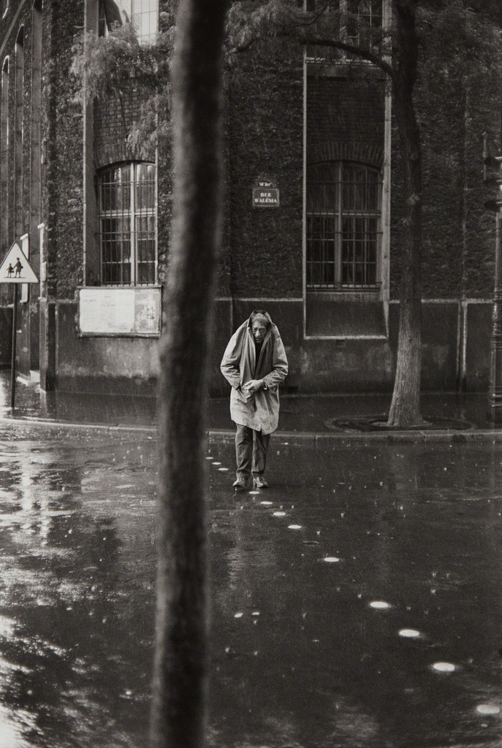
The only thing in Henri’s later life that interests him photographically is portraiture and ‘faces’. In conversation in an interview ‘Just Plain Love’ he picks up on one man specifically, Alberto Giacometti. Praising him on what an intelligent man he was, “He could do anything”, Giacometti was a swiss painter, a photographer, sculptor, draftsman and printmaker- the jack of all trades. Those who love the work of Giacometti and love the work of Cartier-Bresson, are particularly fond of figure 2. (below) This image has been described as an icon, where some sort of reality transcends images. In the case, its’s the affection and admiration, felt by the photographer. “This image shows the movement of a man in relation to his inner self, his absolute being. His way of relating to himself. The covering of his head with his coat sums him up perfectly. It shows the carefree nature of a man who had no umbrella, nor did he have a home. A man who never takes what we call ‘precautions’.” pictured here on a reflective surface, walking on a thin line towards his friends, aware that his way of presenting himself would catch his friends attention and amuse them. (just plain love) But with Henri Cartier-Bresson, the relationship felt in the moment between them both was a moment of trust, the photograph is a response to their respect to each other, it’s a representation of what Henri was looking at. So from Henri’s morality what he looks at is what he loves, and this is represented photographically through his portraits.

Alberto Giacometti

In conclusion, both photographers use the conventions of portraiture in their work to express not only the objective beauty and complex nature of the world, but to represent the relationship, the subjective interaction felt by the subject and themselves in the frame of experience within the worlds they communicate and opperate (the respect for one another). Eve’s approach is the result of extreme immersion in the fantasy of a movie star and the reality of being a human being who feels the same negative and positive aspect of life the same as we all do. Because Eve and Marilyn were both in a situation in which was highly controlled and had an envisioned outcome, (a movie set) they could work together in such a way of finding themselves through each others perspectives. This shows extreme intelligence, openness and a willingness to go into the unknown, to trust it and to see it through to the end.
Cartier- Bresson’s approach was ever so slightly different, coming from a life of chaos, coming from hell, Henri’s eye was tuned to different strings. Geometry and aesthetics were his main satisfactions in making photographs post war, but when it came to portraiture he has some very interesting and insightful things to say about the interactions of human experience.
To me I feel both of these photographers were getting at the same thing, from completely different backgrounds and experiences they were drawn to the inner workings of people in the moment, they loved to chat and immerse themselves with people because they learnt to look, consequently

Extended Bibliography-

Arnold, E. (1959). Joan Crawford, actress (USA), trying to remember her lines during a rehearsal at home. Behind her is Joan as she was in Mildred Pierce. [Photograph] https://www.magnumphotos.com/arts-culture/cinema/eve-arnold-joan-crawford-public-image/, Magnum Photos.

YouTube. (2016). 2016 Personality Lecture 13: Openness and Intelligence. [online] Available at: https://www.youtube.com/watch?v=qRFxulvRC7I [Accessed 10 May 2018].

Arnold, E. (1967). A nun ironing the Cardinals vestiments.. [Photograph] http://pro.magnumphotos.com/C.aspx?VP3=SearchResult&VBID=2K1HZO44BE5KYC&PN=16&IID=2S5RYDY6FBKA, Magnum Photos.

Pro.magnumphotos.com. (2018). Magnum Photos. [online] Available at: http://pro.magnumphotos.com/C.aspx?VP3=SearchResult&VBID=2K1HZO44BERAPS [Accessed 8 May 2018].

YouTube. (2015). The Life of Eve Arnold with Janine di Giovanni and Susan Meiselas. [online] Available at: https://www.youtube.com/watch?v=pgHd0KeHa5E [Accessed 29 Apr. 2018].

YouTube. (2013). Marilyn Monroe And Photographer Eve Arnold Documentary 2/2. [online] Available at: https://www.youtube.com/watch?v=XEugSVqGjt4 [Accessed 1 May 2018].

YouTube. (2013). Marilyn Monroe And Photographer Eve Arnold Documentary 1/2. [online] Available at: https://www.youtube.com/watch?v=GlmqCdleI4I [Accessed 3 May 2018].

YouTube. (2010). Eve Arnold and Josef Koudelka. [online] Available at: https://www.youtube.com/watch?v=LvJAsyt2Rfw [Accessed 1 May 2018].

Pro.magnumphotos.com. (2018). Magnum Photos. [online] Available at: http://pro.magnumphotos.com/C.aspx?VP3=SearchResult&VBID=2K1HZO44BHHPPJ&SMLS=1&RW=1279&RH=655 [Accessed 6 May 2018].

Halvin, L. (2017). A Public Image: Joan Crawford • Eve Arnold • Magnum Photos. [online] Magnum Photos. Available at: https://www.magnumphotos.com/arts-culture/cinema/eve-arnold-joan-crawford-public-image/ [Accessed 12 May 2018].
Arnold, E. (1996). Eve Arnold. 1st ed. London: Sinclair-Stevenson, p.3.
YouTube. (2013). Eve Arnold interviewed about her Marilyn Monroe photos..flv. [online] Available at: https://www.youtube.com/watch?v=4FlN589WnO4 [Accessed 13 May 2018].
Figure 1- Arnold, E. (1960). Marilyn prepares herself for the important sequences at the end of the film. [Photograph] http://uk.phaidon.com/agenda/photography/picture-galleries/2012/january/06/when-eve-arnold-met-marilyn-monroe/, Website.
Stern, C. (2015). Original Marilyn Monroe photos estimated to be worth $6 million. [online] Mail Online. Available at: http://www.dailymail.co.uk/femail/article-3235373/Rare-stills-Marilyn-Monroe-s-iconic-nude-calendar-shoot-1950s-revealed-worth-6-MILLION.html#ixzz5FwJy62YX [Accessed 13 May 2018].
YouTube. (2013). Marilyn Monroe And Photographer Eve Arnold Documentary 2/2. [online] Available at: https://www.youtube.com/watch?v=XEugSVqGjt4 [Accessed 14 May 2018].
YouTube. (2014). Henri Cartier Bresson - Just Plain Love (Documentary). [online] Available at: https://www.youtube.com/watch?v=ZYYwqo8HKbw [Accessed 14 May 2018].
YouTube. (2014). Henri Cartier Bresson - Just Plain Love (Documentary). [online] Available at: https://www.youtube.com/watch?v=ZYYwqo8HKbw [Accessed 14 May 2018].
YouTube. (2014). Henri Cartier Bresson - Just Plain Love (Documentary). [online] Available at: https://www.youtube.com/watch?v=ZYYwqo8HKbw [Accessed 14 May 2018].
Figure 2. Cartier-Bresson, H. (1961). Alberto Giacometti, Rue d'Alesia, Paris. [Photograph, Silver Gelatin Print] https://www.artsy.net/artwork/henri-cartier-bresson-alberto-giacometti-rue-dalesia-paris.

